Question 7: Analyse the use of music in the short film. How is it used to develop character, ideas or mood?

DESCRIPTION
In the opening scene of The Dark Horse, a black screen is shown and the audience hears a long and low constant note in the background. As the visuals start, slow and soulful piano music is played. The rhythm is smooth and constant.
We hear the distant rumble of thunder and intense rainfall. Then a slow and peaceful male voice is heard chanting in Maori, followed by a loud knocking sound.

ANALYSIS
The low constant note in the background suggests that there is always something going on for the character that is shown. The slow speed of the music causes the audience to feel intrigued and sad. There is a pause between each note that has a calming effect on the listener. The piano music slows the listener’s heartbeat and increases their awareness and sensitivity to seeing the man walk down the high street in the rain. The director intended for the audience to be acutely aware of what is going on at the start of the film and for them to empathise with the central character.

HOW IT DEVELOPS THE MOOD?
Overall, the effects of these multiple sounds create a soulful and sad mood to open the film.

Question 7: Analyse the use of music in the short film. How is it used to develop character, ideas or mood?

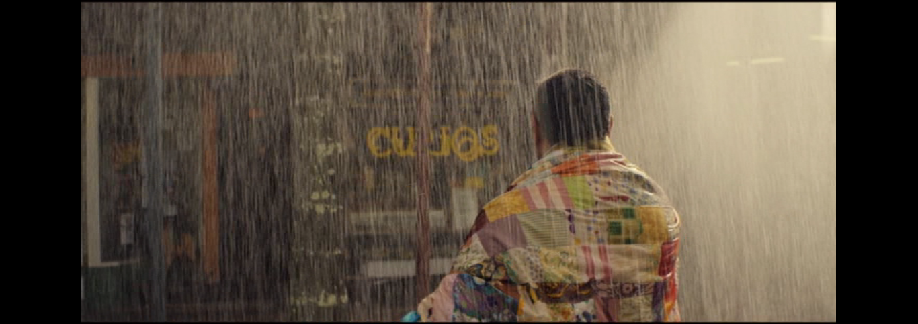
intrigued heartbeat empathise long acutely smooth distant slow intense opening peaceful speed loud black constant calming
DESCRIPTION
In the _________ scene of The Dark Horse, a _______ screen is shown and the audience hears a ______ and low constant note in the background. As the visuals start, ______ and soulful piano music is played. The rhythm is ________ and constant.
We hear the distant rumble of thunder and ___________ rainfall. Then a slow and ______________ male voice is heard chanting in Maori, followed by a loud knocking sound.
ANALYSIS
The low ___________ note in the background suggests that there is always something going on for the character that is shown. The slow _______ of the music causes the audience to feel ___________ and sad. There is a pause between each note that has a ___________ effect on the listener. The piano music slows the listener’s _______________ and increases their awareness and sensitivity to seeing the man walk down the high street in the rain. The director intended for the audience to be ____________ aware of what is going on at the start of the film and for them to ______________ with the central character. Overall, the effects of these multiple sounds create a soulful and sad mood to open the film.

