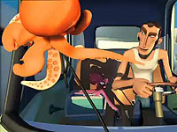 | 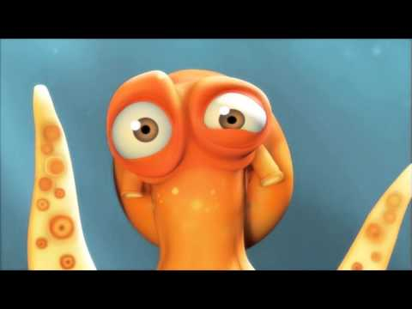
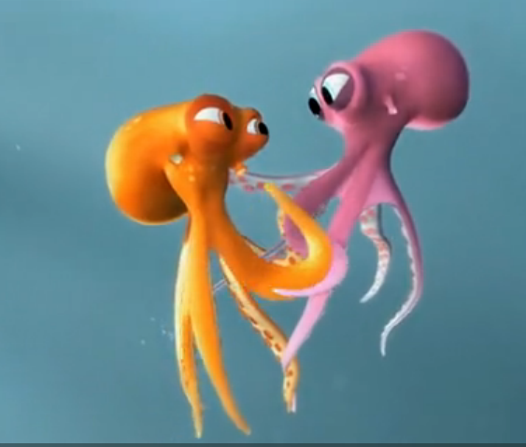 | 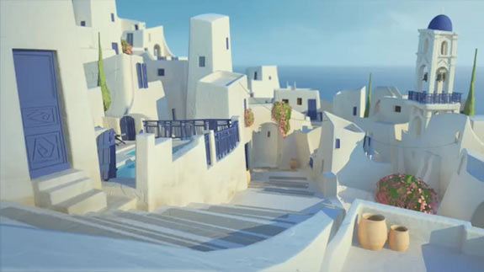
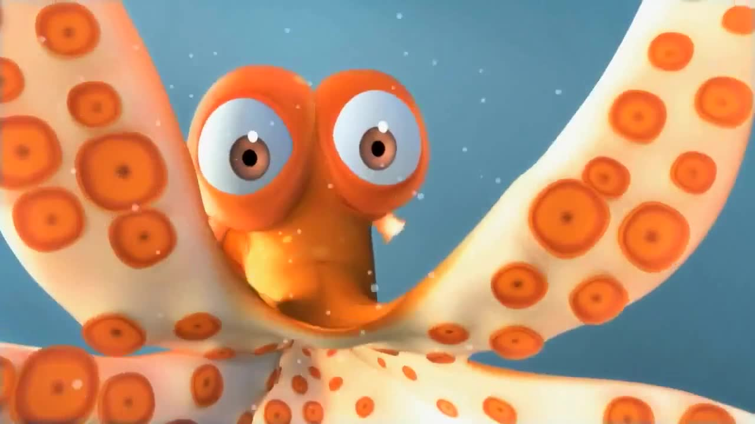 | 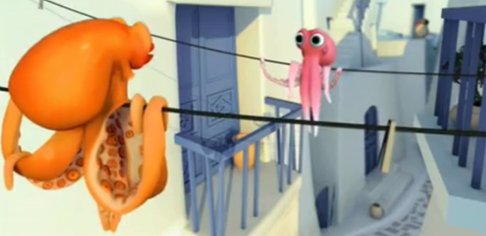

Over the Shoulder Shot | Close Up Shot
Long Shot | Establishing Shot
Close Up Shot | Long Shot

Shows the desperate situation from the orange octupus’s point of view. | Shows the expression of confusion on the character’s face.
Shows love between the two octopi as they stare into each other’s eyes. | Shows the view over the town’s rooftops. There are white houses, blue sky and a blue ocean.
Shows the expression of fear on the character’s face. | Shows the two characters staring at each other as they hang from telephone wires far above the street below.

The directors’ intentions are to make the audience laugh at the same time as feeling empathy for the octopus’s situation. | The directors want to show that the character is confused and frustrated but have also made the octopus’s face humorous to make the audience laugh.
The directors have used the detail of the octopi holding each other’s hands to encourage the audience to feel warmth about the loving relationship. | The directors show an overview of the town to help the audience identify the location as Greece and cause viewers to admire the beautiful location.
The directors create humour for the audience by framing the shot with tentacle legs and by making the octopus’s eyes extremely wide. | The directors want the audience to feel relieved that the two have escaped their hunter but also he wants us to laugh at the new problem they face.

