Technique | Example | Description
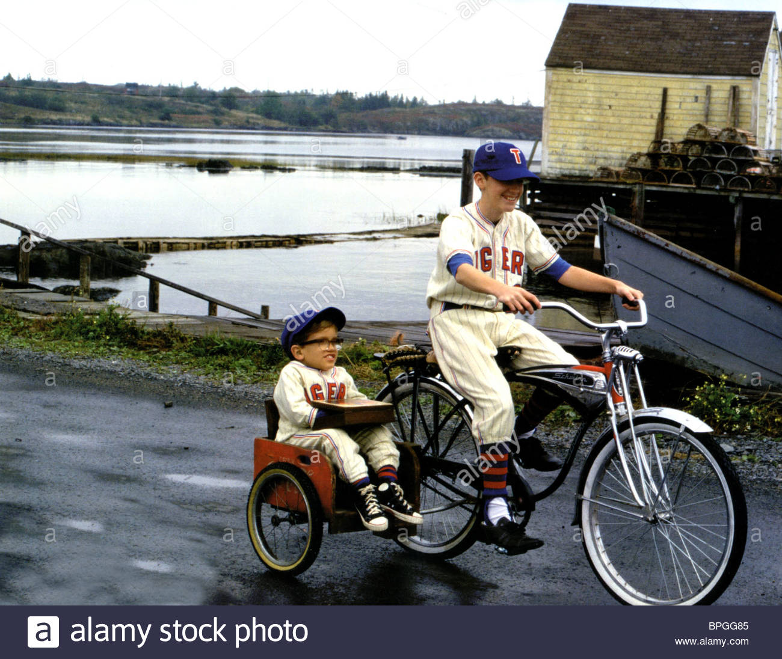 | A long shot | In this long shot, you can see Simon and his friend, Joe Wentworth riding along in their village. The long shot allows you to see the boys in their environment. They live in desolate village beside a lake and the sky is grey. Joe rides the bike but Simon is too small so he is in the pillion cart.
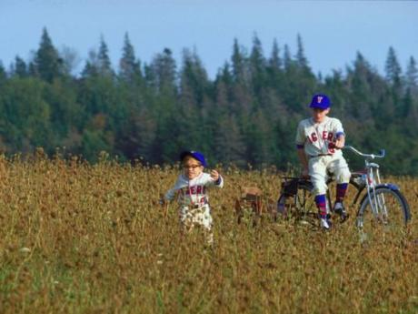 |  | Describe the environment. Name the people. Say something about the purpose of the shot.
