FORMATIVE FILM TEST – JUNIORS
NAME __________________________________
- film shots
 | Shot | Name of shot
1 | 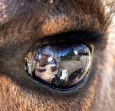
2 | 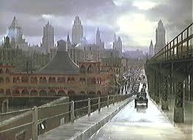
3 | 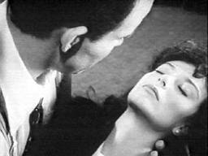
4 | 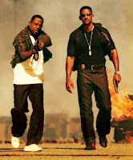
5 | 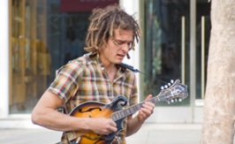
6 | 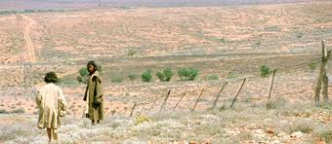
7 | 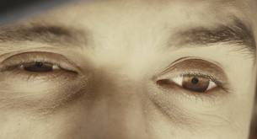
8 | 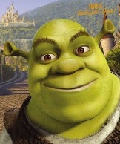
9 | 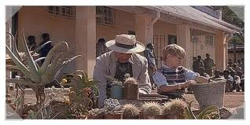
10
- MUSIC
Describe these musical clips (use as many adjectives as you can)
Think about instruments, mood and speed.
 | Shot | Description of music and mood
1 |  | https://www.youtube.com/watch?v=rn9V0cN4NWs
2 | 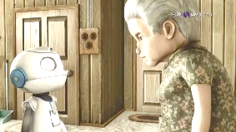 | https://www.youtube.com/watch?v=EVq69CtYkpw
3 | 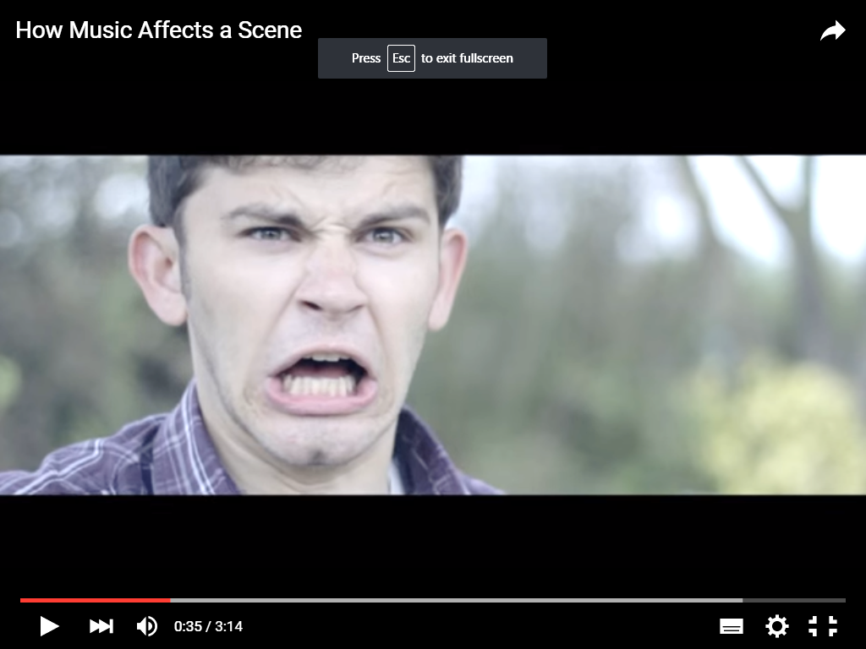 | https://www.youtube.com/watch?v=ovEYV0GAV2k
4 | 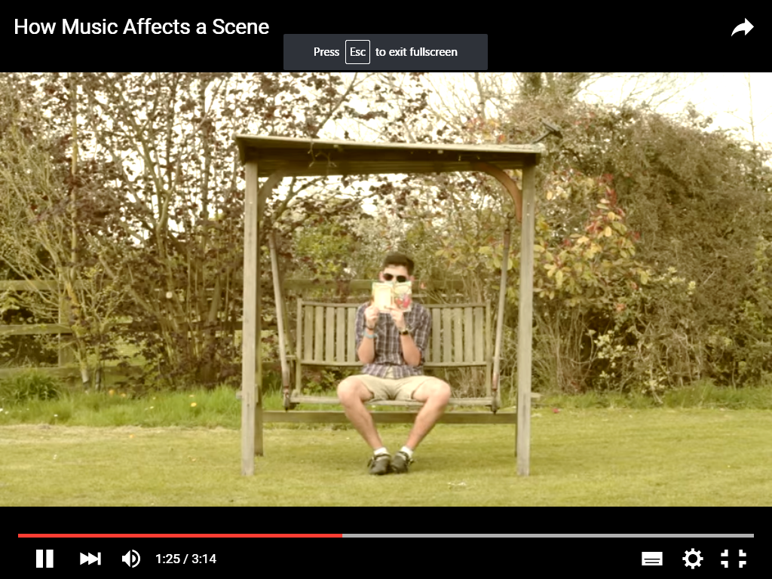 | https://www.youtube.com/watch?v=ovEYV0GAV2k
5 | 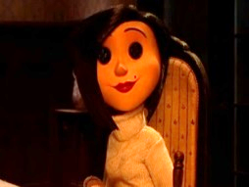 | https://www.youtube.com/watch?v=haW0vKj99tk
6 | 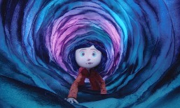 | https://www.youtube.com/watch?v=jFUpkE3C7ro
7 |  | https://www.youtube.com/watch?v=tcn4UWZLFr8
8 | 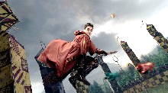 | https://www.youtube.com/watch?v=8GwXBBuQRJA&index=10&list=PLYXfr3Na3Iuf8Kg__C6Fll5bapkVOXp9b
9 |  | https://www.youtube.com/watch?v=vnYgnVXYXTY
10 |  | https://www.youtube.com/watch?v=NTHz9ephYTw
Words to help you:
scary, sad, rock, triumphant, suspicious, tense, funky, eerie, upbeat, energising, epic, exciting,
haunting, intense, Indian, victorious, thoughtful, sinister, mysterious, tense, urgent, chilled
- Colour
Explain the colour meanings and name the colour to match the meaning.
 | Colour | Description of meaning
1
2
3
4
5
 | Meaning | Colour
6 | Magical
7 | Love
8 | Warmth
9 | Calmness
10 | Energy

- Lighting
Just name the colour/type of lighting but you should write detailed sentences in the description box.
 | Shot | Colour/ Type | Description of meaning
1 | 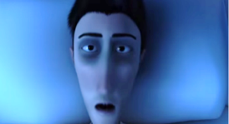
2 | 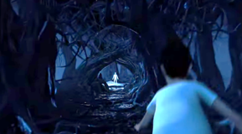
3 | 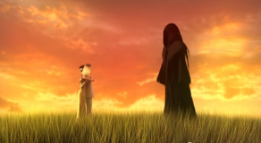
4 | 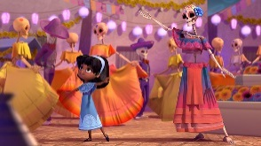
5 | 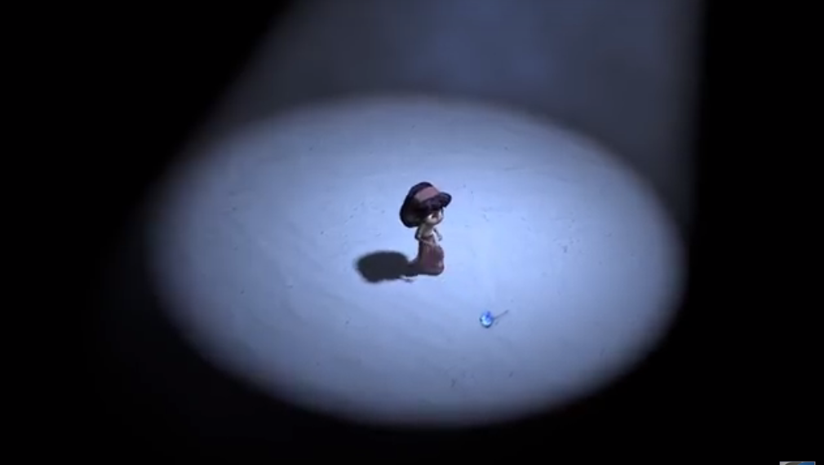

- PARAGRAPH WRITING
Use this space to write a paragraph about ONE SCENE from a short movie that we have watched. You can choose from: Bully, El Dia de los Muertos, Big Game, Oktapodi or In Sickness.
Try to follow the format given to write about the scene.
TEXAS – Topic, Example, Explanation, Analysis, Summary
You will be given extra marks if you can combine film techniques in your response. Eg. Film shot plus music plus colour. Also, try to include information on the audience response to the scene.

