Close up shot  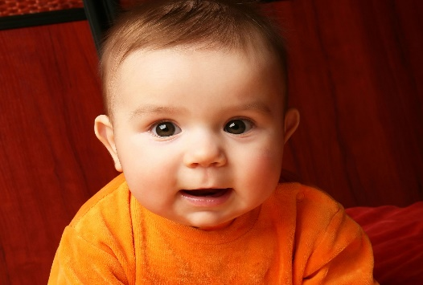 | A close up shot usually shows the face in detail so that facial expression can be seen.  The shoulders are usually in the shot, but not always.
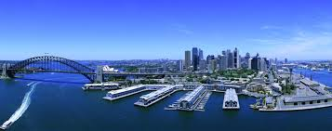  Aerial Shot | An aerial shot or high angle shows the character/subject from above. It is also known as a bird's eye view.
Establishing Shot  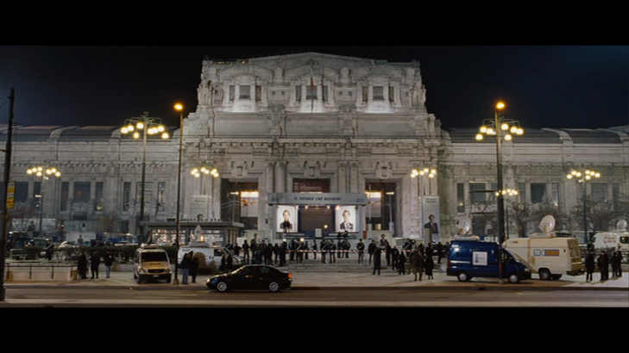 | An establishing shot indicates where and when the action is taking place. It is a shot from a distance that sometimes shows the character in the location.
Long Shot  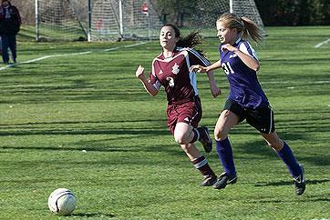 | A long shot shows the full length of the actor's body.

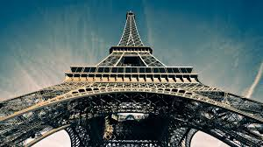  Low angle shot | A low angle shot shows the subject from below. The camera is held at a low angle to shoot the subject.
Over the shoulder shot  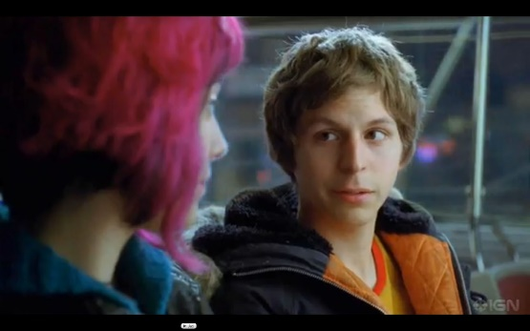 | An over the shoulder shot includes one person's shoulder on the edge of the frame.
Slow motion  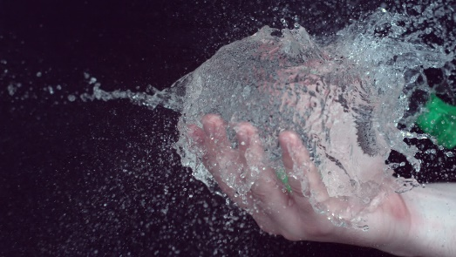 | The deliberate slowing down of the speed of the film so that everything is seen more slowly than in real life.
High angle shot  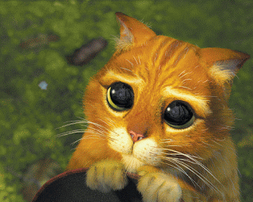 | High angle shots are usually used in film to make the moment more dramatic or if there is someone at a high level that the character below is talking to.

