How to Train Your Dragon
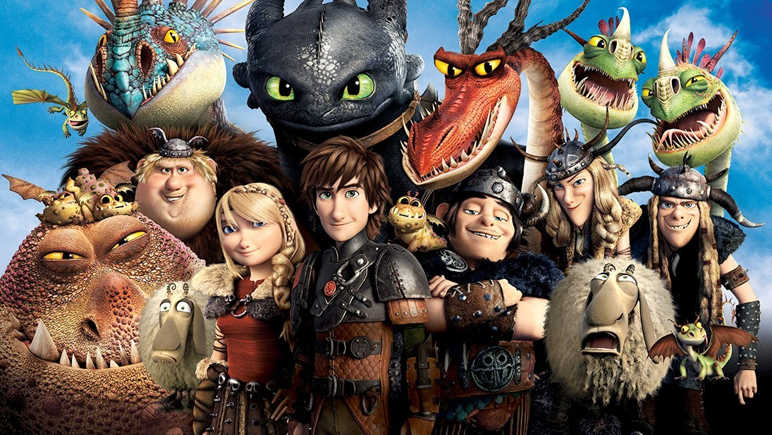
Match the character with the characteristic and the explanation using arrows.

Character |  | Characteristic | Reason Why
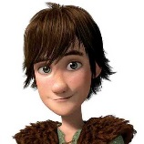 | Hiccup | Daring | Because he doubts Tuffnut’s explanation  about the tattoo being a birthmark
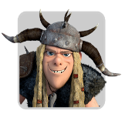 | Tuffnut | Determined | Because he makes a dragon tail out of leather
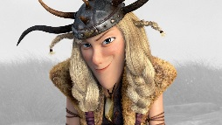 | Ruffnut | Ambitious | Because she is always trying her best to kill dragons
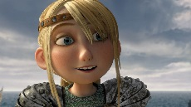 | Astrid | Challenging | Because she wants to be the most successful dragon slayer.
 | Hiccup | Inventive | Because he gets a tattoo.
 | Astrid | Aggressive | Because he fixes the dragon tail onto Toothless, even though the tail keeps moving around

