EXPLANATION OF VOCABULARY THAT MAY BE USEFUL IN DESCRIBING THE BEHAVIOUR IN THE HELP

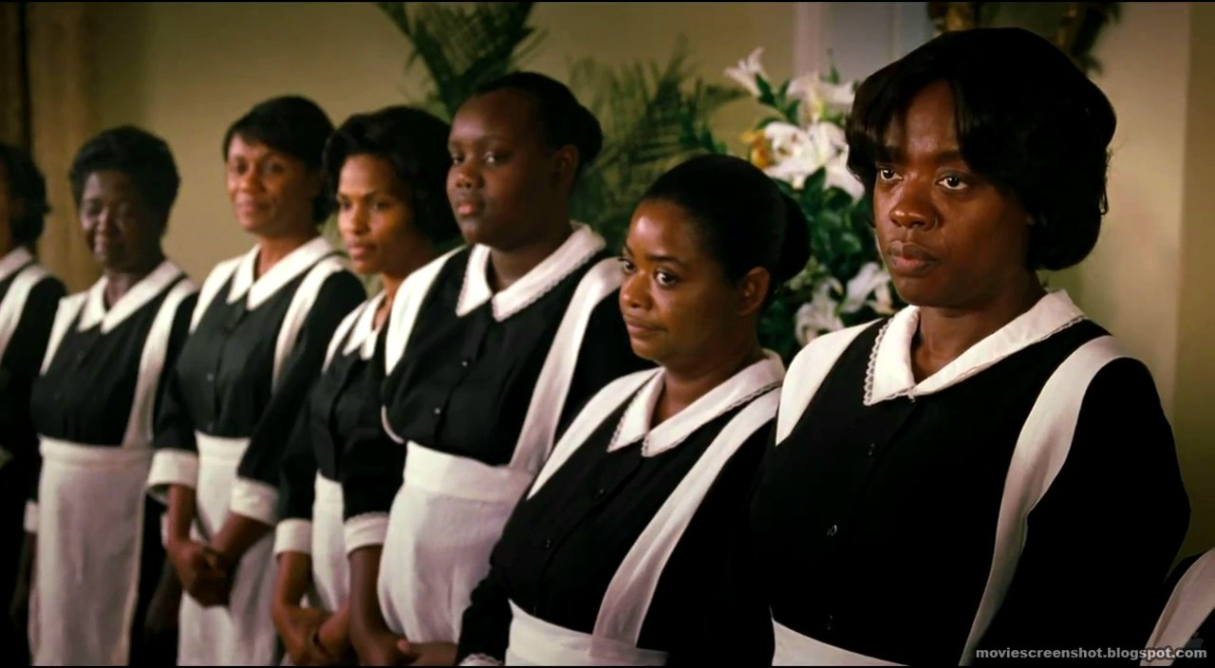

- etiquette is the common code (often unspoken) of polite behaviour
- rhetoric is a common conversation in society about deeper meaning (often insincere)
- cherry-picking means selectively choosing the best from what is available
- perpetrators are the people doing bad things e.g. the criminal
- gamut is the complete range of something
- compulsion the urge to behave a certain way
- ostracize means to exclude from a society or group
- spate a large number of things in quick succession
- counter-attack is a second attack made in response to a first attack
- hypocrisy acting like those who you criticize
- hypercritical is being excessively critical of small faults
- narrow-mindedness means not being open to new ideas
- a notion is an idea
- virtuous is having high moral standards
- yearning is a feeling of intense longing for something
- a superiority complex is an attitude of being superior (usually used to hide feelings

of inadequacy)
- an inferiority complex is an unrealistic attitude of being inferior caused by being treated inadequately
- originate means comes from or starting from
- bigotry is intolerance toward others who hold different opinions from yourself
- disparaging is expressing an opinion that something has little worth
- inflammatory is intended to arouse feelings of anger
- inherent is something that exists inside a person and is not able to be separated from them
- harbor (in this context) means to hold thoughts secretly
- harmonious means trouble-free, pleasing, lacking in disagreements, peaceful
- exemplify means to show a typical example of
- squander means to waste something
- divisive is causing disagreement or hostility between others
- prejudice is a pre-decided opinion, not based on actual experience
- irreverent means showing a lack of respect for people or things that should be taken seriously

