ESTABLISHING SHOT | LONG SHOT | CLOSE UP SHOT
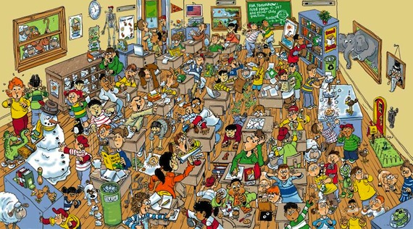 | 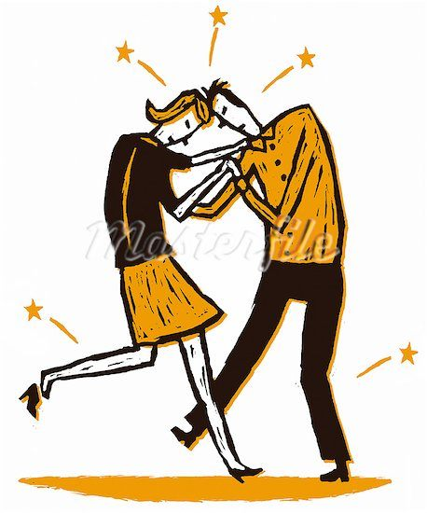
A busy classroom with lots going on | Accidental collision of 2 teachers | “Ouch! That hurt!”
Fast music & shadowy light | Loud intense music & dark or bright light | Normal light & loud scream
2 SHOT or OVER SHOULDER MID SHOT | CLOSE UP SHOT | EXTREME CLOSE UP & CANTED ANGLE
 | 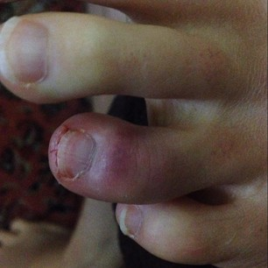
Are you okay? | Look! | Ooooh I feel funny!
Caring music & soft light | Light enough to see injury…intense music
LONG SHOT | LONG SHOT | CLOSE UP
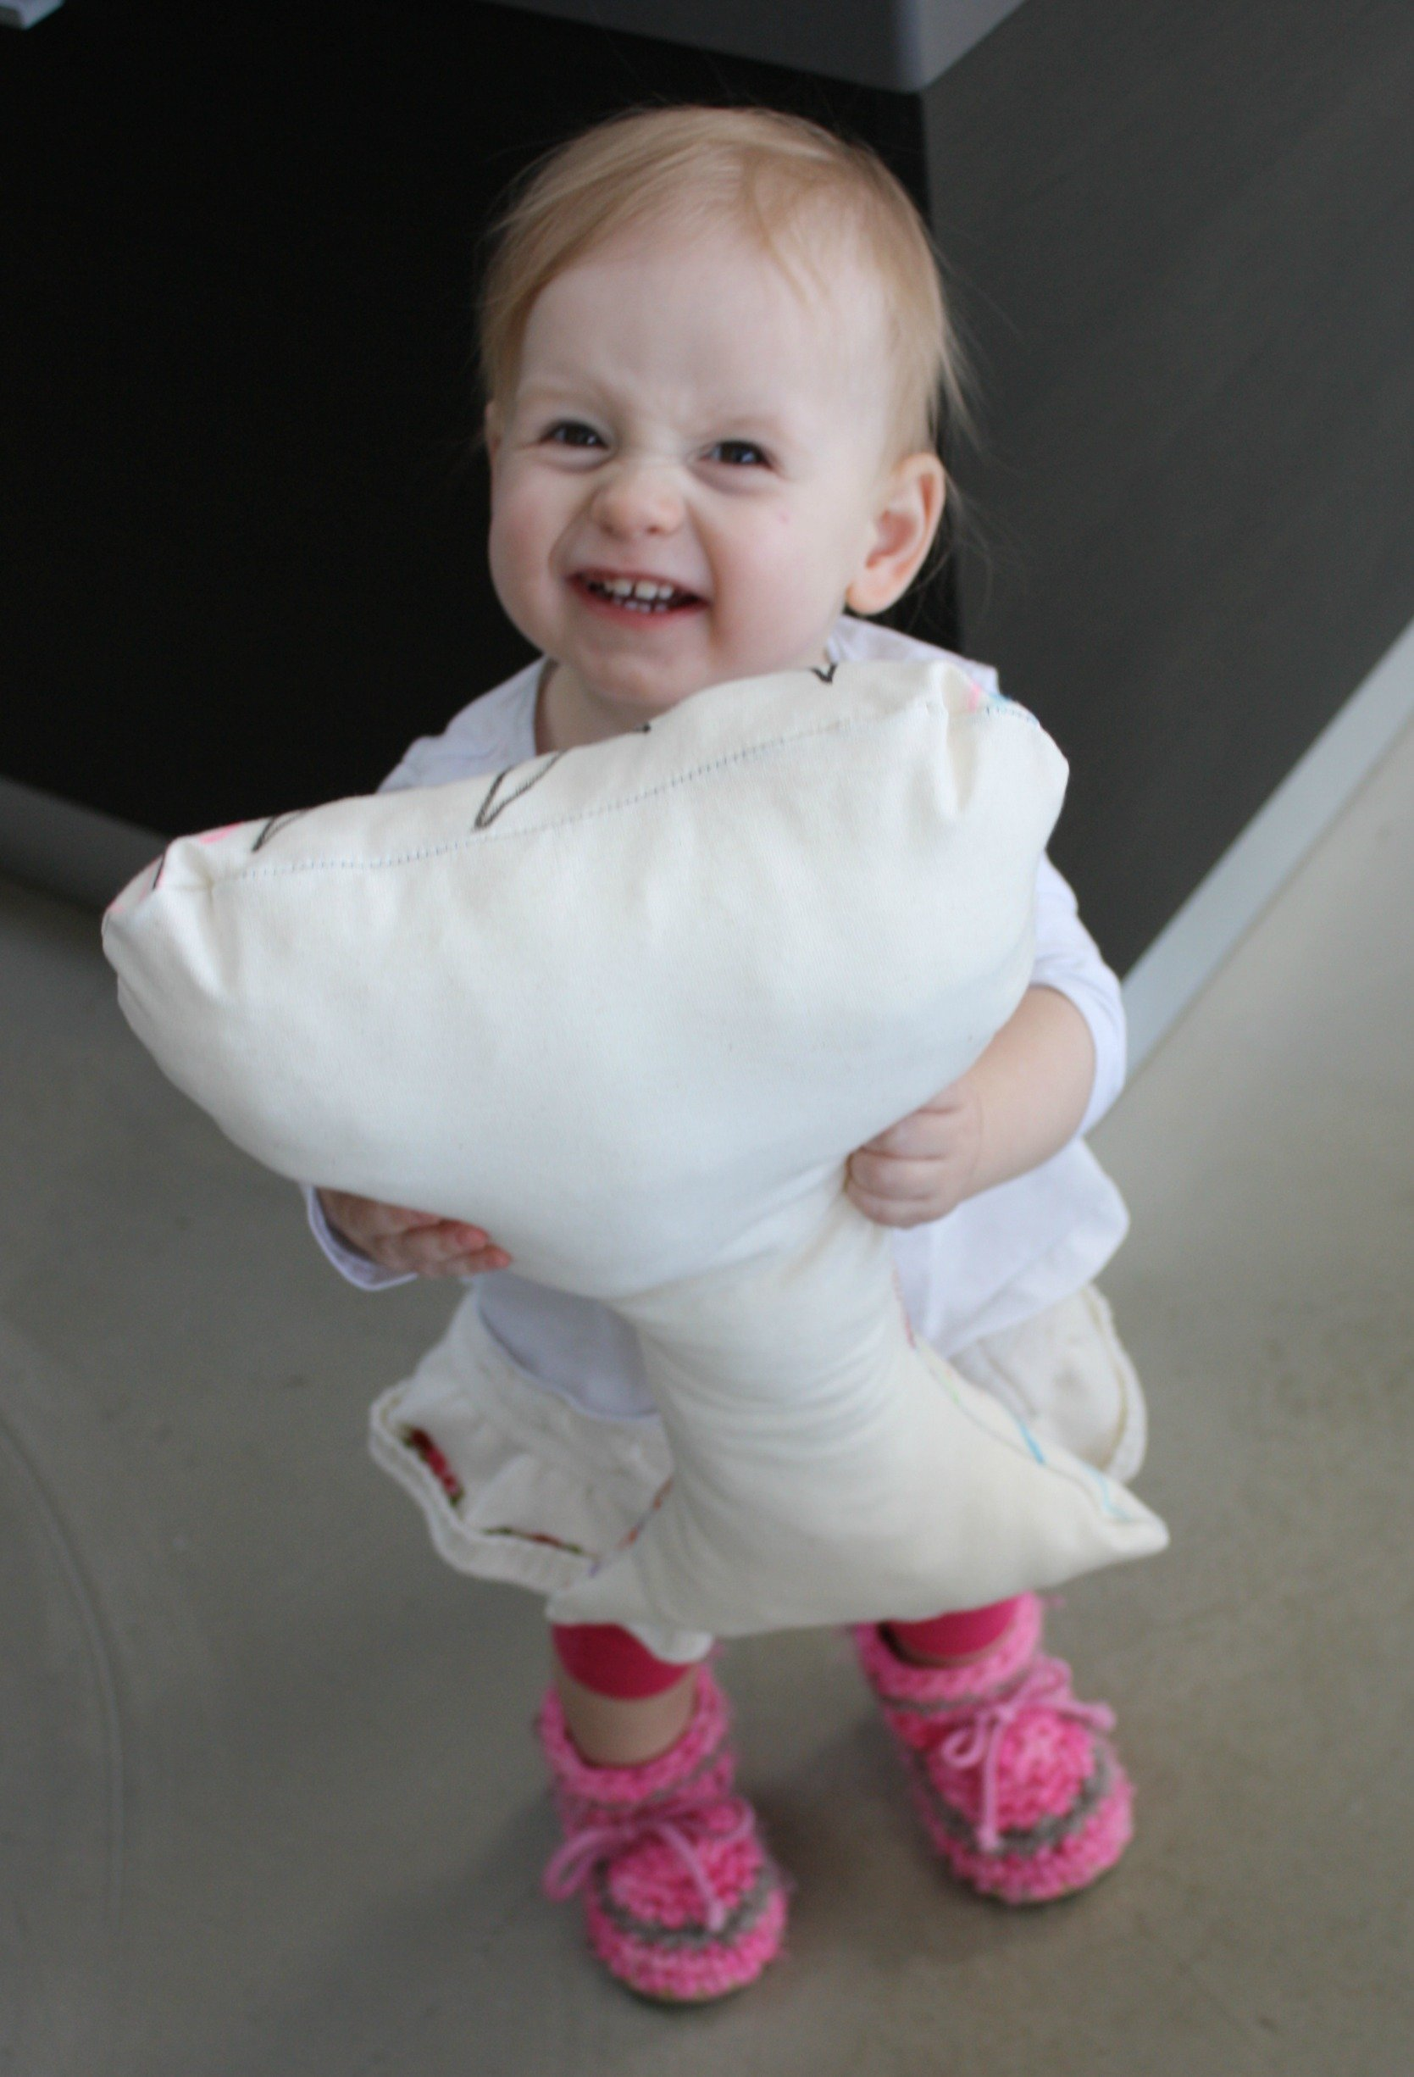 | 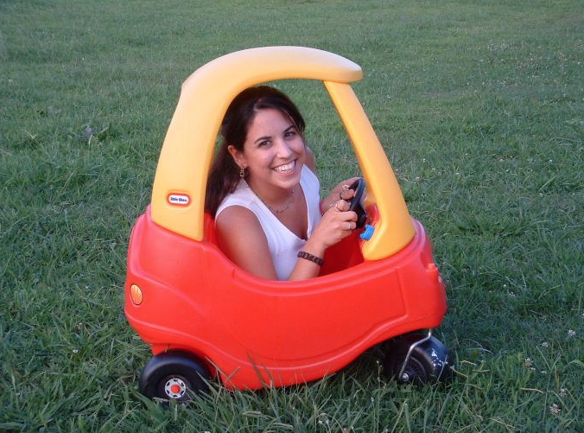 | 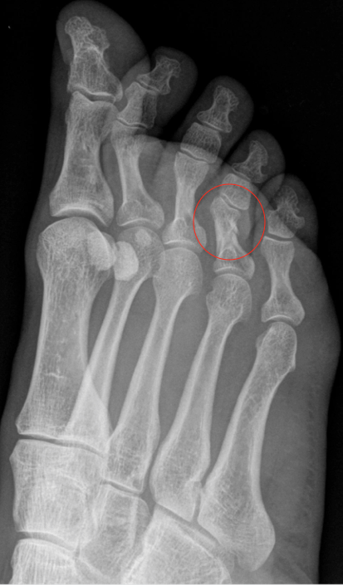
Do you want a pillow? | You need to see the doctor! | It’s broken!

